Digital Logic Design

QUIZ#4

Section A

Roll#-------------------------------

Q1. (5 MARKS)

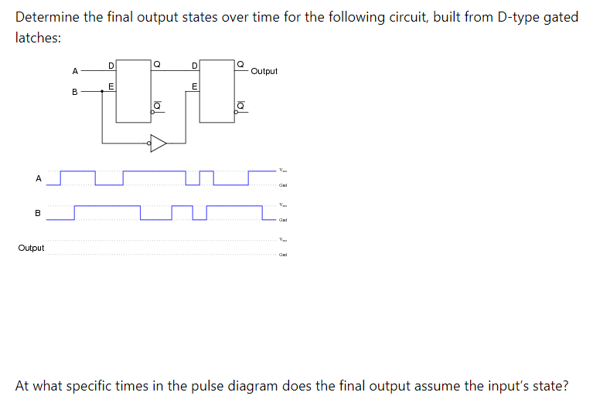

Solution:

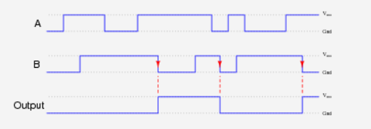

Q2. (5 Marks)

1. Make a Characteristic Table and write down characteristic equation for SR NAND Flip Flop (with control). (1.5+1.5 =3)
2. How SR NAND Flip Flop (with control) is modified to form D Flip Flop? (2)

Solution:

a)

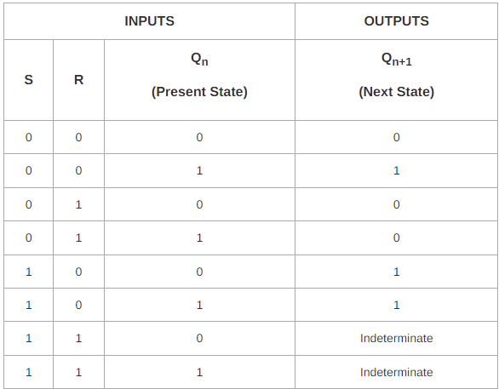



b)

